Terraform CI/CD

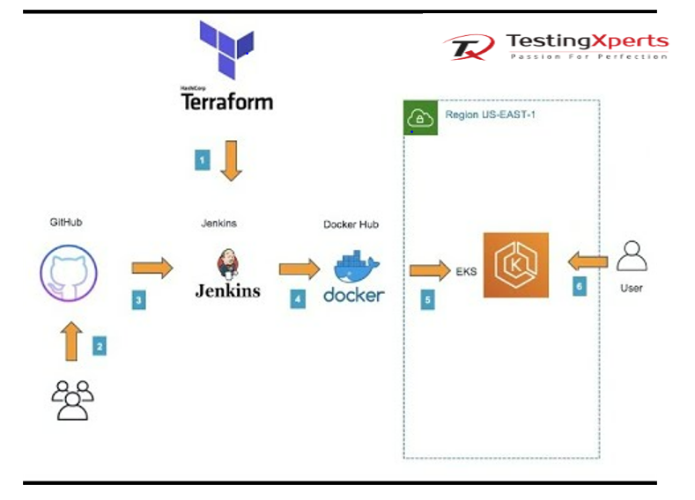

Terraform
Terraform is a tool for building, changing, and versioning infrastructure safely and efficiently. It is controlled via an easy-to use command line interface (CLI). As the configuration changes, Terraform is able to determine what changed and create incremental execution plans which can be applied. The key features of Terraform are: Infrastructure as Code, Execution Plans, Resource Graph, and Change Automation.

Jenkins
Jenkins is a self-contained, open source automation server which can be used to automate all sorts of tasks related to building, testing, and delivering or deploying software. It can be installed through native system packages, Docker, or even run standalone by any machine with a Java Runtime Environment (JRE) installed.

Prerequisites
To implement the instructions in this post, you will need the following:
- AWS account
- Docker Hub account
- GitHub account
Overview of steps:
- Create a Jenkins CI server using Terraform.
- Configure Jenkins.
- Configure Jenkins job and pipeline.
- Create and configure Spinnaker pipelines.
- Modify code and push the code change using AWS Cloud9.
- Clean up

Create a Jenkins CI server using Terraform
Provisioning a Jenkins CI server manually can be error-prone and time-consuming, so I shall be configuring the Jenkins Continuous Server (CI) using Infrastructure as Code (IaC). For this post, I have decided to use Terraform. Log in to the AWS Management Console and create an EC2 key pair your GitHub account, fork the code sample repository at
From the AWS Cloud9 IDE, open a shell terminal and do the following (replace aws-samples with your GitHub account):
provider "aws" {
region = "ap-southeast-1"
}

terraform {
backend "s3" {
bucket = "eks-terraform-state-statging"
key = "eks/terraform2.tfstate"
region = "us-west-2"
}
}

data "aws_ami" "amazon-linux-2" {
most_recent = true
owners = ["amazon"]
filter {
name = "name"
values = [
"amzn2-ami-hvm-*-x86_64-gp2",
]
}
filter {
name = "owner-alias"
values = [
"amazon",
]
}
}

resource "aws_instance" "jenkins2-instance" {
ami = "${data.aws_ami.amazon-linux-2.id}"
instance_type = "t2.medium"
key_name = "${var.keyname}"
#vpc_id = "${aws_vpc.development-vpc.id}"
vpc_security_group_ids = ["${aws_security_group.sg_allow_ssh_jenkins.id}"]
subnet_id = "${aws_subnet.public-subnet-1.id}"
#name = "${var.name}"
user_data = "${file("install_jenkins.sh")}"

associate_public_ip_address = true
tags = {
Name = "Jenkins2-Instance"
}
}

resource "aws_security_group" "sg_allow_ssh_jenkins" {
name = "allow_ssh_jenkins"
description = "Allow SSH and Jenkins inbound traffic"
vpc_id = "${aws_vpc.development-vpc.id}"

ingress {
from_port = 22
to_port = 22
protocol = "tcp"
cidr_blocks = ["0.0.0.0/0"]
}

ingress {
from_port = 8080
to_port = 8080
protocol = "tcp"
cidr_blocks = ["0.0.0.0/0"]
}

egress {
from_port = 0
to_port = 0
protocol = "-1"
cidr_blocks = ["0.0.0.0/0"]
}
}

output "jenkins_ip_address" {
value = "${aws_instance.jenkins2-instance.public_dns}"
}

module "eks" {
source = "terraform-aws-modules/eks/aws"

cluster_name = "my-cluster-demo"
cluster_version = "1.21"
cluster_endpoint_private_access = true
cluster_endpoint_public_access = true

cluster_addons = {
coredns = {
resolve_conflicts = "OVERWRITE"
}
kube-proxy = {}
vpc-cni = {
resolve_conflicts = "OVERWRITE"
}
}

vpc_id = "vpc-166cda71"
subnet_ids = ["subnet-c62e468f","subnet-7caba63a","subnet-2f017948"]

#########################
eks_managed_node_groups = {
green = {
min_size = 1
max_size = 1
desired_size = 1

instance_types = ["t3.medium"]
capacity_type = "SPOT"
subnet = "subnet-2f017948"
labels = {
Environment = "test"
GithubRepo = "terraform-aws-eks"
GithubOrg = "terraform-aws-modules"
}
}
}
}

git clone https://github.com/KalashPalwanda/demoIac1.git
cd /KalashPalwanda/terraform/
terraform init
terraform plan
terraform apply -auto-approve
Bash

- Terraform apply will also output the IP address of the Jenkins CI server as shown above.
- Terraform will provision an AWS EC2 instance and install git, Apache Maven, Docker, Java 8, and Jenkins as shown in the install_jenkins.sh file:

- #!/bin/bash
- sudo yum -y update

- echo "Install Java JDK 8"
- sudo yum remove -y java
- sudo yum install -y java-1.8.0-openjdk-devel

- echo "Install Maven"
- sudo yum install -y maven

- echo "Install git"
- sudo yum install -y git

- echo "Install Docker engine"
- sudo yum update -y
- sudo yum install docker -y
- sudo usermod -a -G docker jenkins
- #sudo chkconfig docker on
- sudo service docker start
- sudo chmod 666 /var/run/docker.sock

- sudo amazon-linux-extras install epel -y
- sudo yum update –y
- sudo yum -y install wget
- sudo wget -O /etc/yum.repos.d/jenkins.repo https://pkg.jenkins.io/redhat-stable/jenkins.repo
- sudo rpm --import https://pkg.jenkins.io/redhat-stable/jenkins.io.key
- sudo yum upgrade
- sudo yum install jenkins java-1.8.0-openjdk-devel -y
- sudo systemctl daemon-reload
- sudo systemctl start jenkins
- sudo ufw allow 8080

Using a browser, open the page at http://jenkins_ip_address:8080; the Jenkins admin page will be displayed:

After that in local : run

kubectl create clusterrolebinding cluster-system-anonymous --clusterrole=cluster-admin --user=system:anonymous
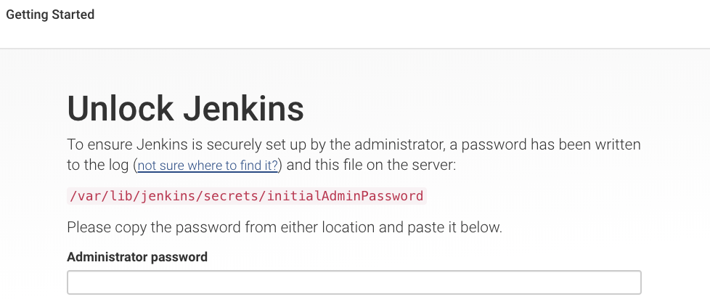

Configure Jenkins
1. Plugins:
Log in to the Jenkins console, click Manage Jenkins → Manage Plugins → Available. Choose and install Docker plugin and GitHub Integration Plugin, then restart Jenkins by clicking the Restart Jenkins check box as shown here:
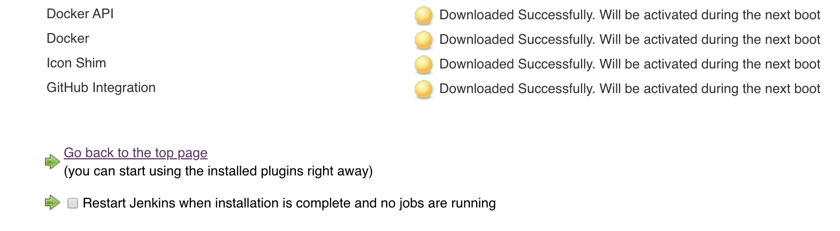
2. Credentials:
Docker Hub: Click Credentials → global → Add Credentials, choose Username with password as Kind, enter the Docker Hub username and password and use dockerHubCredentials for ID.
GitHub: Click Credentials → Global → Add Credentials , choose Username with password as Kind, enter the GitHub username and password and use gitHubCredentials for ID.

pipeline {
agent any
triggers {
pollSCM "* * * * *"
}
stages {
stage('Build Application') {
steps {
echo '=== Building Application ==='
sh 'mvn clean package'
}
}
stage('Test Application') {
steps {
echo '=== Testing ==='
sh 'mvn test'
}
post {
always {
echo '=== hello ==='
}
}
}
stage('Build Docker Image') {
when {
branch 'master'
}
steps {
echo '=== Building Docker Image ==='
script {
app = docker.build("username/imagename")
}
}
}
stage('Push Docker Image') {
when {
branch 'master'
}
steps {
echo '=== Pushing Docker Image ==='
script {
GIT_COMMIT_HASH = sh (script: "git log -n 1 --pretty=format:'%H'", returnStdout: true)
SHORT_COMMIT = "${GIT_COMMIT_HASH[0..7]}"
docker.withRegistry('https://registry.hub.docker.com', 'dockerHubCredentials') {
app.push("$SHORT_COMMIT")
app.push("latest")
}
}
}
}

stage('K8S Deploy') {
steps {
kubernetesDeploy(
configs: 'kubernetes/petclinic.yaml',
kubeconfigId: 'K8s',
enableConfigSubstitution: true
)
}
}

stage('Remove local images') {
steps {
echo '=== Delete the local docker images ==='
sh("docker rmi -f kalashpalwanda/demo:latest || :")
sh("docker rmi -f kalashpalwanda/demo:$SHORT_COMMIT || :")
}
}
}
}

